# Revision 1 note:

Preliminary design advances are recorded in this revision.

# Introduction

A conceptual design for the TLM was brought to life in the lengths of a 10’, 125’, 250’, and 338’. These TLMs were installed and successfully tested at the Antiproton Source at the Accumulator. Construction details and test results have been reported in the Pbar electronic logbook. Links to this work can be found at <http://www-muon.fnal.gov/Personnel/Leveling/TLMs.htm> The purpose of this document is to describe design changes for the Preliminary Design TLM.

# Design Change Drivers

The TLM design is based up the HJ5-50, HELIAX® Standard Air Dielectric Coaxial Cable [Figure 1]. The bias voltage is applied to the outer shield while the signal is collected from the center conductor. Argon gas flow is established between the outer shield and the center conductor to prevent the buildup of vapor from the polyethylene which could alter the characteristic behavior of the intended argon detector gas.

Strong evidence for the possibility of gas poisoning was observed during initial TLM setup in 2011. An argon gas purge was established through a new length of TLM cable with the exhaust gas routed to a bubbler/container filled with DI water. After several hours of purging the cable at a low flow rate, a strong odor resembling isopropyl alcohol could be detected in the bubbler volume. Since the cable was manufactured and no gas exchange was possible, the speculation is that following manufacturing of the cable, the newly formed PE insulator could outgas into the space between the shield and center conductor. This gas was removed during initial purging of the cable and combined with bubbler water where it was surreptitiously discovered.



Figure 1: HJ5-50, HELIAX® Standard Air Dielectric Coaxial Cable

In the conceptual design, two gas hoses were routed to the ends of each TLM cable. One hose was connected to the center conductor so that the tube could be purged initially and subsequently isolated. The second hose carried gas into the region between the inner conductor and the outer shield. Gas flow through the center conductor is wasted since radiation detection of ionized gas does not occur there. Another conceptual design consideration was that the signal wire connection should be made inside of the center conductor. There was some concern that if the signal wire was soldered to the outside of the center conductor, that some detector end effects could occur in which a disproportional ion chamber signal might develop if the signal wire was too close to the outer shield at the bias voltage. To accommodate these concerns, the signal wire was soldered to the inside of the center conductor. A hole was made near the end of a piece of 3’8” plastic tubing through which the signal wire could be routed. The plastic tube was subsequently installed over the end of the inner conductor and then clamped in place with a tie-wrap. This conceptual design detail is shown in Figure 2.

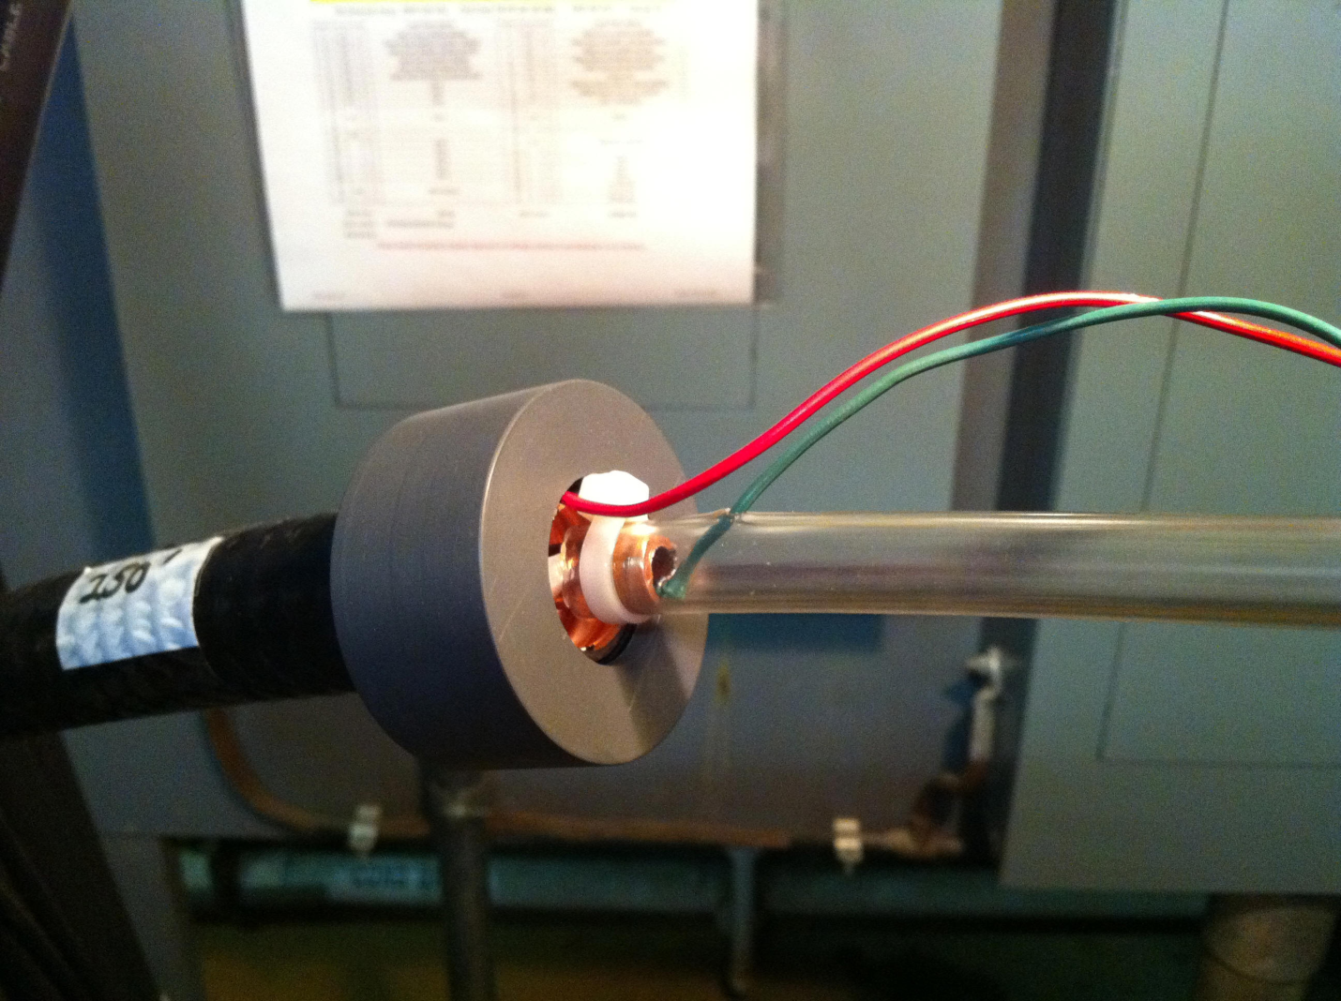

Figure 2: The green wire is the signal wire soldered to the inside of the inner conductor. A length of plastic tubing separates the inner conductor gas volume from the outer gas volume. The red wire, soldered to the outside of the outer conductor carries the detector bias voltage.

In the preliminary design, the center conductor gas volume is isolated from the outer volume by a threaded, sealed closure so that the control of gas in the center conductor is no longer required. This design change became feasible when the possibility of significant detector end effects was eliminated during TLM testing. In the preliminary design, the signal wire is soldered to a lug which is attached to the end of the inner conductor.

The gas type and gas pressure chosen for conceptual design was argon at atmospheric pressure. All testing to date has been done with argon at near atmospheric pressure and no reason has been found to change detector gas. A total of 5 TLMs including a 1’, 10’, 125’, 250’, and 338’ were installed for testing at the Antiproton Source. The gas flow was directed through each of the detectors serially to minimize gas usage. One new idea was tried to pressurize the TLM cables in series at 1 psig or as a way to monitor the presence of the gas source. It soon became clear that the TLMs were not leak tight. Gas could leak through SHV connectors, BNC connectors, and the inner conductor gas isolation tube where it passed through the PVC end caps. In the final design, it is envisioned that gas will flow serially through as many TLMs as possible to conserve gas usage. To ensure gas does flow through long sections of TLM cable, it is important to make the TLMs gas tight.

The TLM conceptual design did not include a heartbeat function. To emulate the chipmunk performance, some sort of detector heartbeat is required to provide assurance that all aspects of the TLM system are in working order. The chipmunk has a Cs-137 source affixed to its ion chamber to ensure charge production and current flow from the ion chamber. The Radiation Safety System specifically monitors for this heartbeat and interrupts the RSS in the event the heartbeat is not produced. Before a analogous technique could be developed for the TLM system, it was necessary to characterize TLM system performance, establish a detector bias voltage, and establish dynamic range requirements. Since this work has been completed, a TLM heartbeat design has been chosen. A 500 volt bias is to be supplied to the detector outer conductor on the same end of the TLM cable that the signal cable is attached. It has been determined that a 10 Tohm resistor connected across inner and outer conductors at the end opposite of the TLM cable would provide a 3 nC/min background signal which would appear in 3 TTL pulses each with a represented charge of 1 nC. As a result of this design decision, it has been determined that the ends of the TLM cable can be terminated identically. This is an improvement over the conceptual design which used different termination schemes depending upon which end was to be connected to the electrometer.

The gas line interconnections for the conceptual design TLM was simple plastic tubing. The preliminary design uses ¼” NPT to ¼” brass compression fittings threaded into each end cap. Copper tubing, ¼” O.D., will be used to run gas line interconnections in the preliminary design. This design change anticipates the installation of TLMs in areas where plastic tubing degradation might occur due to high level beam losses.

Resistor box must be grounded for safety

# Detailed Preliminary TLM Design

A description of the detailed TLM construction features will be described here. Both ends of the TLM are to be prepared by these instructions.

GENERAL CAUTIONS:

1. Cleanliness of the ion chamber internal surfaces is very important. Prevent cuttings, dirt, debris from entering the ion chamber volume, especially between the inner and outer conductor.
2. When using the tubing cutter to cut the outer PE and copper outer conductor, do not use more force than necessary to cut the tubing. Deformation of the outer conductor by excessive tubing cutter force can crush the outer conductor inward towards the inner conduction which must be avoided.
3. The TLM cable ion chamber end connectors are assembled with epoxy. It is important to make joints with sufficient material so that gas tight integrity is achieved.

Cable end preparation

Refer to Figure 3.

1. Cut the outer PE insulation and outer copper shield with a tubing cutter which can accommodate a 7/8” OD cable.
2. Slide the cut parts off of the end of the inner conductor and PE standoff.
3. Cut the PE standoff flush with the end of the outer shield.
4. Trim the inner conductor to length. Mark center conductor at 5/8” from the end of the outer shield. Cut center conductor at mark with tubing cutter.
5. Deburr sharp edges of outer shield. Preventing copper cuttings/filings from entering the space between the inner and outer conductors.
6. Deburr the outer surface cleanliness requirements

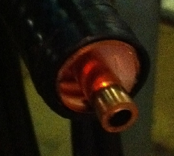

Figure 3: Prepared Heliax cable end

Inner conductor termination

Refer to Figures 4 and 5.

1. Ream the inner conductor to remove sharp edge produced by tubing cutter.
2. Tap inner conductor to a depth of about ¾” with 5/16-24 tap.
3. Install 5/16” long, 5/16-24 outside, 6-32 inside, threaded steel insert.
4. Install lug and brass screw into insert and tighten.
5. Bend lug upwards away from the inner conductor by 90 degrees.
6. Apply solder seal across brass screw, lug, and copper inner conductor around the entire seating area.

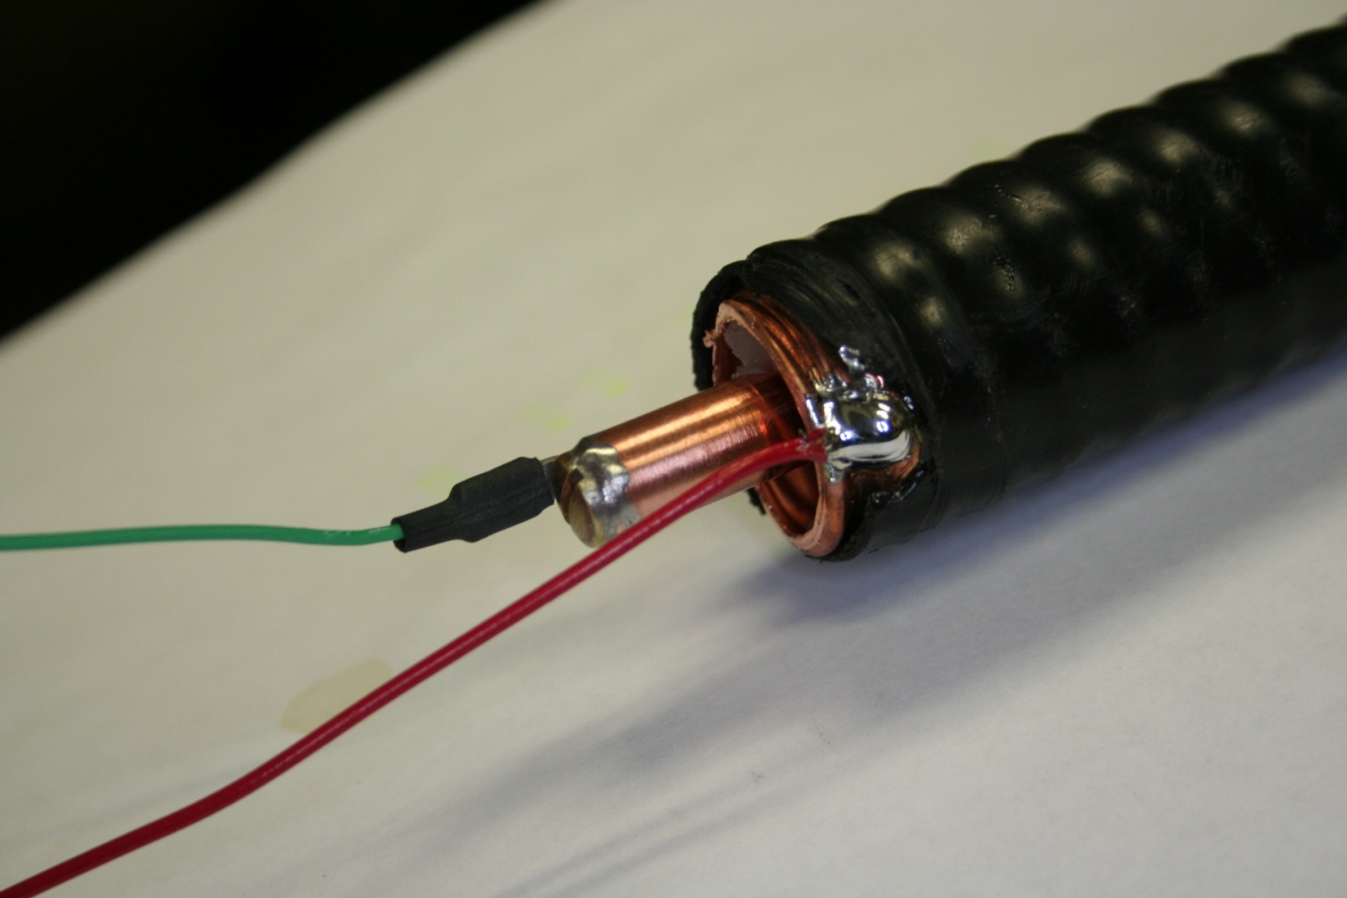

Figure 4: Inner and outer conductor termination prior to end cap installation.

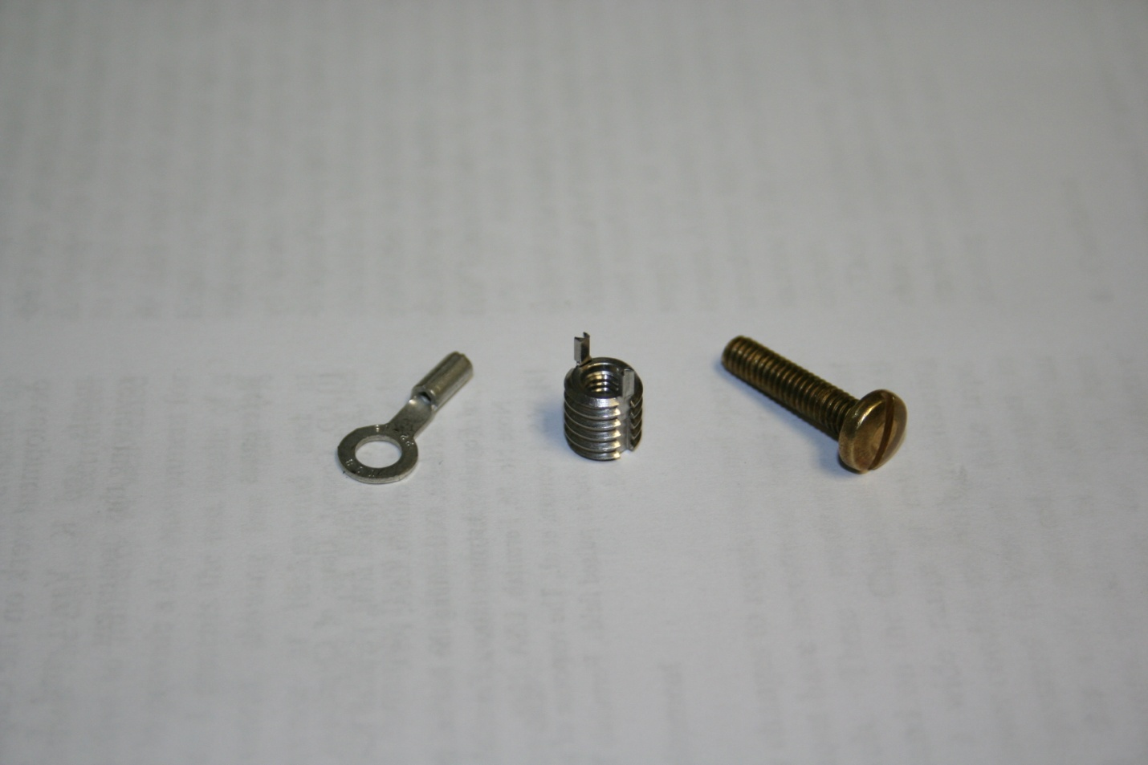

Figure 5: Center conductor lug, threaded insert, and 6-32 x 3/4” brass screw

Outer conductor termination

Refer to Figure 4.

1. Cut notch in PE outer jacket insulation approximately ¼” X ¼”

End Termination Assembly

These assembly steps describe building of the end terminal. After the end terminal is built and leak tested, the assembly is installed on the TLM cable.

1. Mark one side of end cap “outside”
2. Use template (see Figure 6) to mark 3 hole locations on outside of end cap
3. From outside, drill one 7/16” hole and make threads with ¼” NPT tap
4. From outside, drill two 11/32” holes and make threads with 3/8-32 tap
5. Prepare a small quantity of Scotch-Weld 1838 B/A Epoxy, (green epoxy)
6. Apply wetting coat of epoxy to 3/8-32 threads in end cap
7. Apply a 3/16” diameter bead of epoxy to flat of panel mount, BNC threads. If there is no flat, distribute the epoxy across the threads.
8. SLOWLY, thread panel mount BNC into one of the 3/8-32 holes. Turning slowly allows epoxy to creep and results in a good seal.
9. Repeat steps 7 & 8 for the panel mount SHV connector.
10. See Figure 7 & 8 for example of completed subassembly. Allow 24 hours for epoxy to set.
11. Solder green wire to BNC pin.
12. Solder red wire to SHV pin.
13. Prepare a quantity of Scotch-Weld 1838 B/A Epoxy, (green epoxy).
14. Apply a thin layer of epoxy to the PVC housing in the end cap seating area.
15. Apply a layer of epoxy to the outer circumferential surface of the end cap.
16. Insert end cap (wires go inside) into PVC housing.
17. Wipe off excess epoxy. Ethyl alcohol is effective to clean surface.
18. Allow 24 hours for the epoxy to set.
19. Insert a piece of plastic tubing into a ¼” hose barb. (see photo)

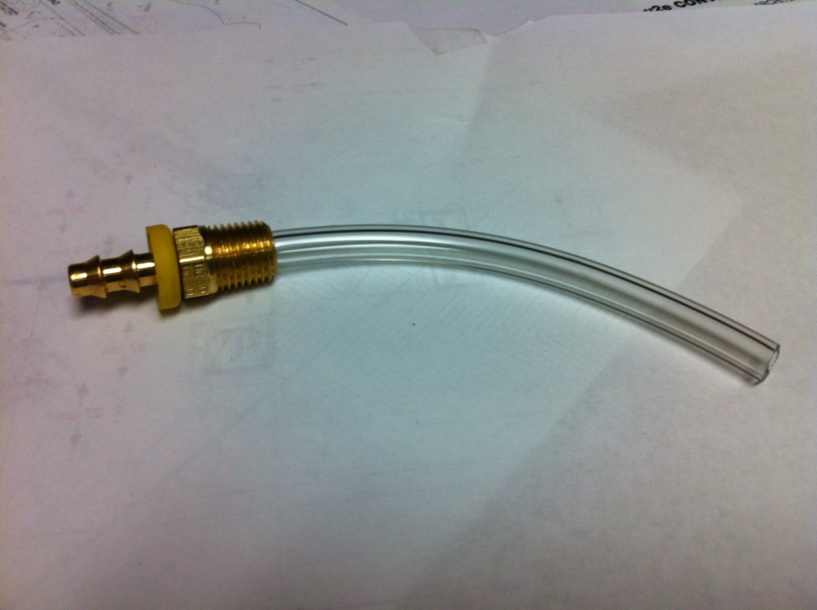

1. Install the hose barb into the end cap. Ensure that the plastic tube and red and green wires are not entangled.
2. Prepare a 50 cc batch of DEVCON 5 minute epoxy (14250).
3. With the end cap positioned vertically, carefully pour the 5 minute epoxy into the end cap. Try to pour the material to the bottom of the end cap avoiding the plastic tube and red and green wires.

NOTE: gas bubbles are entrained in the 5 minute epoxy after setting. This does not appear to affect the insulating properties of the set epoxy.

NOTE: An epoxy with a longer working time may be used. Care must be taken to position the end cap in the following step so that the epoxy sets with the BNC and SHV connectors submerged. Longer working time epoxy may allow gas bubbles to rise to the surface before epoxy sets.

1. Before the epoxy sets, tip/position the end cap so that the SHV connector is below the surface of the epoxy. The shorter BNC connector should remain below the level.
2. After the epoxy has set (about 15 minutes for 5 minute epoxy), remove the plastic tubing from the end cap. Ensure that the resulting gas through hole is clear.
3. Prepare a quantity of Scotch-Weld 1838 B/A Epoxy, (green epoxy).
4. Apply a thin layer of epoxy to the PVC housing in the cable adapter seating area.
5. Apply a layer of epoxy to the outer circumferential surface of the cable adapter.
6. Route green and red wires through cable adapter and insert cable adapter into PVC housing.
7. Wipe off excess epoxy. Ethyl alcohol is effective to clean surface.
8. Allow 24 hours for the epoxy to set.
9. 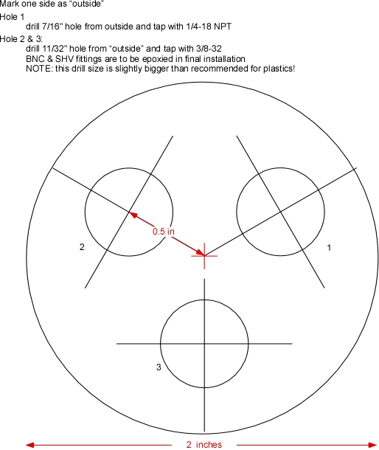

FIGURE 6: PVC end cap plan

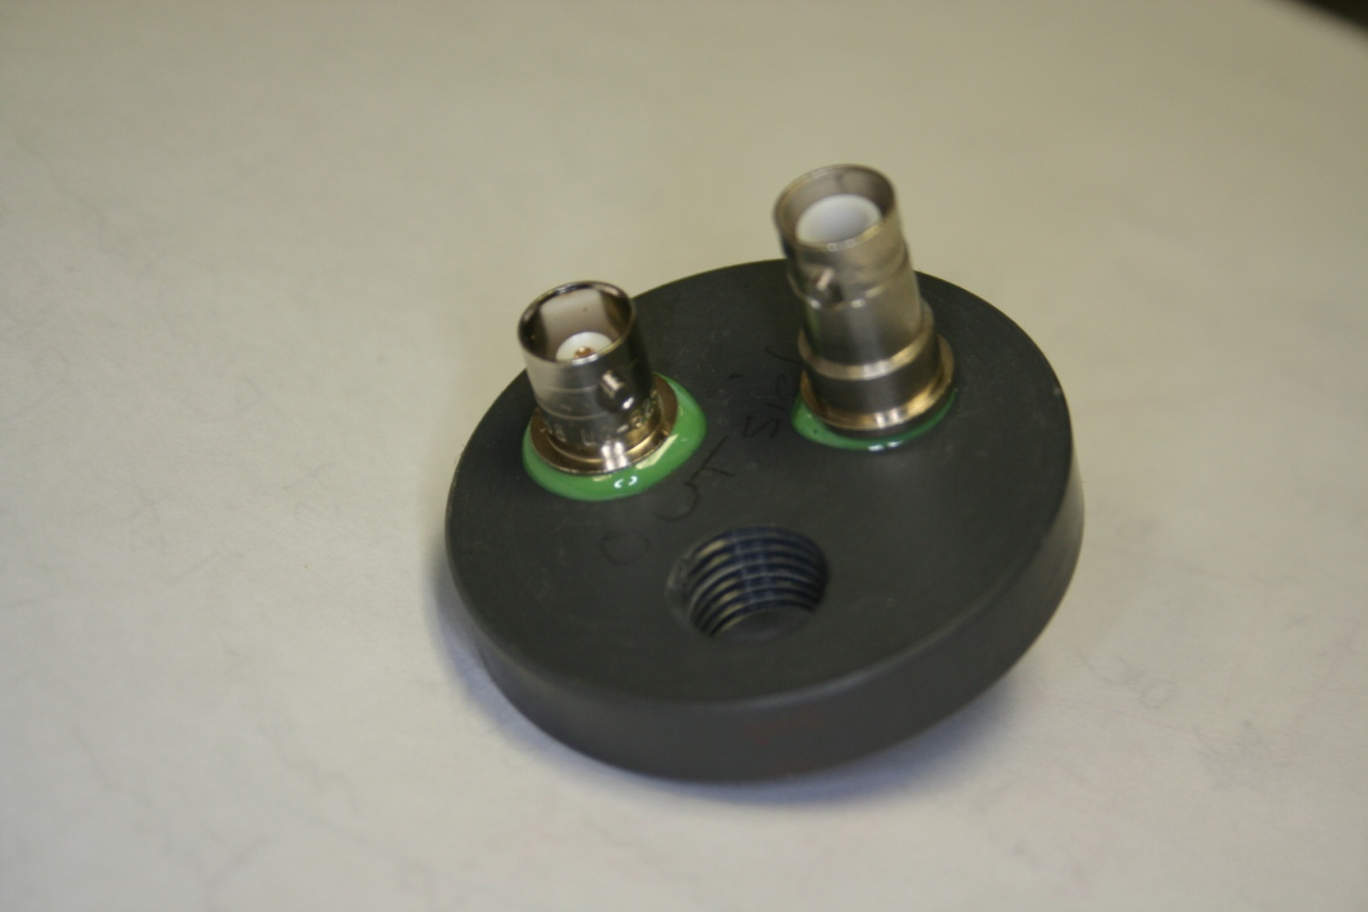

Figure 7: End cap with installed BNC and SHV connectors – outside view

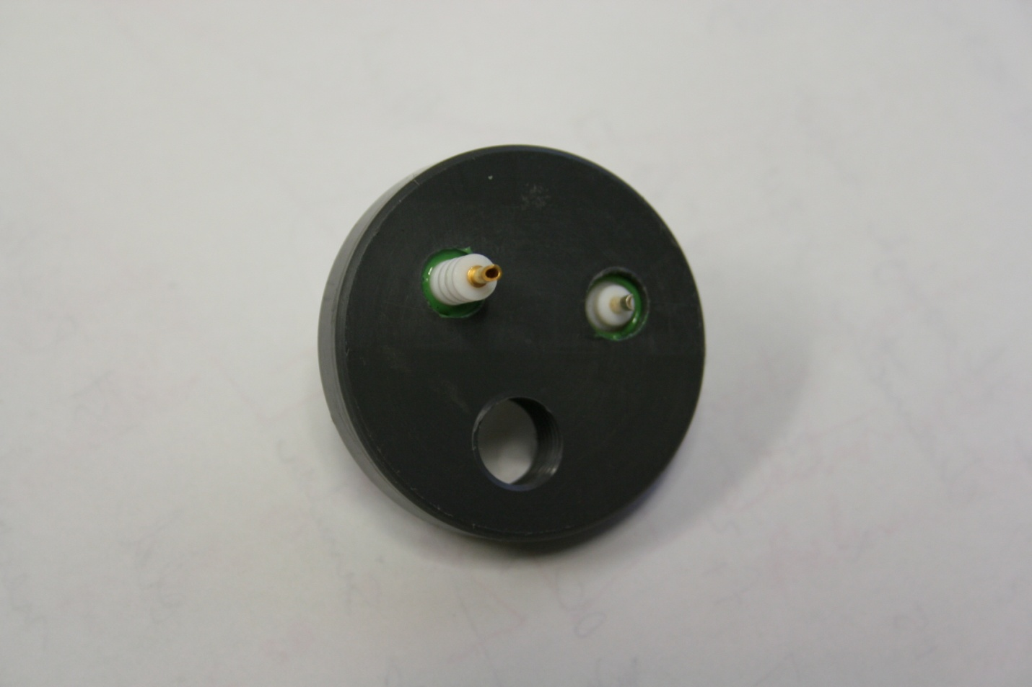

Figure 8: End cap with installed BNC and SHV connectors – inside view

End Terminal Installation on Heliax Cable

Refer to Figure 4.

1. Solder red wire to outer shield at notch.
2. Install a short length of heat shrink tubing on the green wire.
3. Solder green wire on center conductor lug.
4. Position the heat shrink tubing on the solder lug and apply heat to insulate the solder lug.
5. Prepare a quantity of Scotch-Weld 1838 B/A Epoxy, (green epoxy).
6. Apply a layer of epoxy to the cable adapter seating area.
7. Install end termination on Heliax cable. Partially insert the cable into the end cap and withdraw it to spread epoxy on the cable surface. Repeat partial insertion/removal until end cap bottoms out on cable
8. Wipe off excess epoxy. Ethyl alcohol is effective to clean surface.
9. Position the cable end and end cap to prevent the end cap movement while the epoxy sets. If necessary, apply duct tape to temporarily hold the end connector in place.
10. Allow 24 hours for the epoxy to set.
11. Remove duct tape.

Resistor Box Design

PARTS LIST:

1. Pomona 2906 Aluminum Box, die cast, 4.25" x 2.64" x 1.71", cover and screws included.  
   <http://www.alliedelec.com/search/productdetail.aspx?sku=70197973>  
     
   2. SHV connector is Fermi stock 1435-211500 CONNECTOR, RECEPTACLE, FRONT BULKHEAD MOUNTING, D-TYPE HOLE, NIM-SHV TO SOLDER CONTACT, KINGS 1704-1 OR TYCO 51494-2, FEMALE, TARNISH RESISTANT -  
   EA, $ 5.30   
   <http://www.alliedelec.com/search/productdetail.aspx?SKU=70088907>  
     
   3. BNC connector is Fermi stock 1435-405000 CONNECTOR, RECEPTACLE, BNC, BULKHEAD, FRONT MOUNTING, REXOLITE INSULSILVER FINISH, KINGS P/N KC-71-11, OR KC79-48, AMPHENOL #5575 UG-625/U -  
   EA, $ 2.80   
   <http://www.alliedelec.com/search/productdetail.aspx?SKU=70142976>

Assembly:  
Lacking a D-hole punch for the connector mounting, use a drill suitable for the width at the D flat and elongated the hole to accommodate the round part of the mounting flange.  
  
Holes are drilled in the first and third sections on the long side of the box.  A better spacing would be to match the lead spacing on the resistor.    
  
De-burr all holes.  Wipe inside of box with ethyl alcohol.  Clean connectors with alcohol.  Wearing gloves, insert connectors and tighten appropriately.  Clean interior of box and connectors again.    
  
Tin connectors  using 1.1% No-Clean Kester solder.  Avoid the solder with water soluble flux as it has been known to cause conductivity problems on boards.  
Solder resistor into place by handling only on leads with clean tools.  
  
Resistor is suspended by leads.  One may consider using low density polyethylene or polystyrene foam blocks to support the body of the resistor if lead stress is a concern.  
  
Attach cover with screws provided.  
Metal enclosure, drill holes for mounting terminals, wash thoroughly with alcohol, handle all components with gloves to prevent sources of resistor contamination, install BNC/SHV panel mount terminals, solder 10 Tohm resistor – ensure soldering fume deposition on resistor is prevented, close up box after ensuring it’s clean and dry.

End Cap Gas Fitting Installation

Install ¼” NPT X ¼” compression fitting in end cap. Use several turns of Teflon tape on the NPT threads to ensure a gas-leak tight connection is made.

First Gas Leak Test Note (obsolete following end cap epoxy potting)

A 10’ TLM was assembled during the week beginning 10/15/12 using the foregoing assembly procedure. A gas leak test was started on 10/24/12 at 0805. A 0-30 psig gage was attached to one end of the 10’TLM, essentially sealing the heartbeat resistor end. The nominal gas supply was slowly pressurized to 5 psig and then isolated from the TLM. The gage pressure was about 5.5 psig as shown in Figure 9.

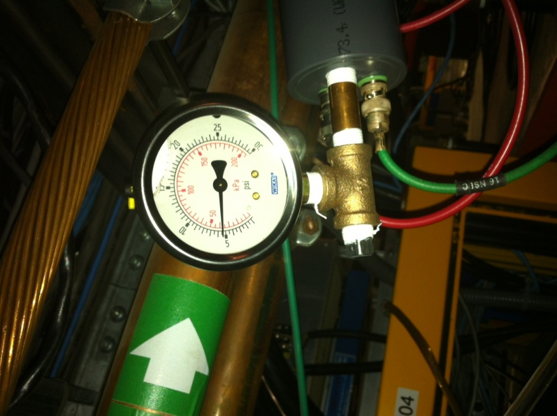

FIGURE 9: Gas leak test arrangement and starting pressure on 10/24/12 at 0800.

Note that 2 hours later, the gas pressure had dropped to 0 psig.

On 10/25/12, changed the gas pressure test arrangement to allow recording of the gas pressure leak rate with a Setra pressure transducer on A:TLMGP1. The leak rate can be seen in Figure 10.

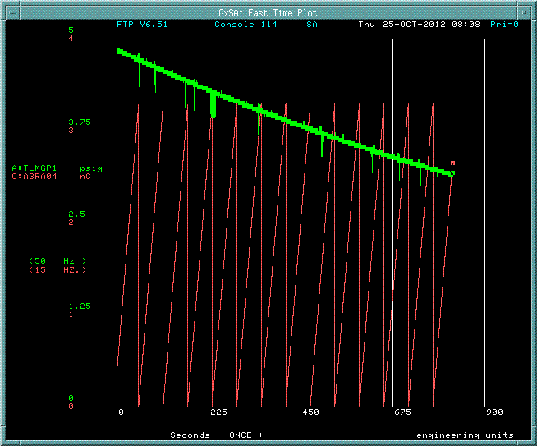

FIGURE 10: Gas pressure leak rate on 10’ TLM.

After changing the plumbing for the gas pressure test, noted that the charge collection rate increased to about 350 nC/min. After checking numerous cable electrical connections, cable grounds, and cable routing, removed the gas pressure applied to the TLM and did an argon gas purge. The charge collection rate rapidly decreased over period of several minutes to the nominal 3.25 nC/minute. The only explanation is that some gaseous contaminant produced during the gas pressure fixture test assembly made a significant change to the dielectric constant of the TLM cable. Water vapor from a previously used ¼” needle valve, pipe thread sealant, and Teflon tape were possible sources of a contaminant. Since the gas purge was finished and a 5 psig gas pressure was applied to the TLM cable, the charge collection rate has started to increase at a very low but measureable rate as can be seen in Figure 11.

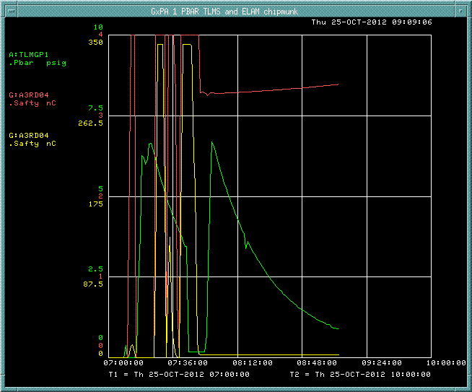

FIGURE 11: Charge collection rate increases gradually during TLM pressure test.

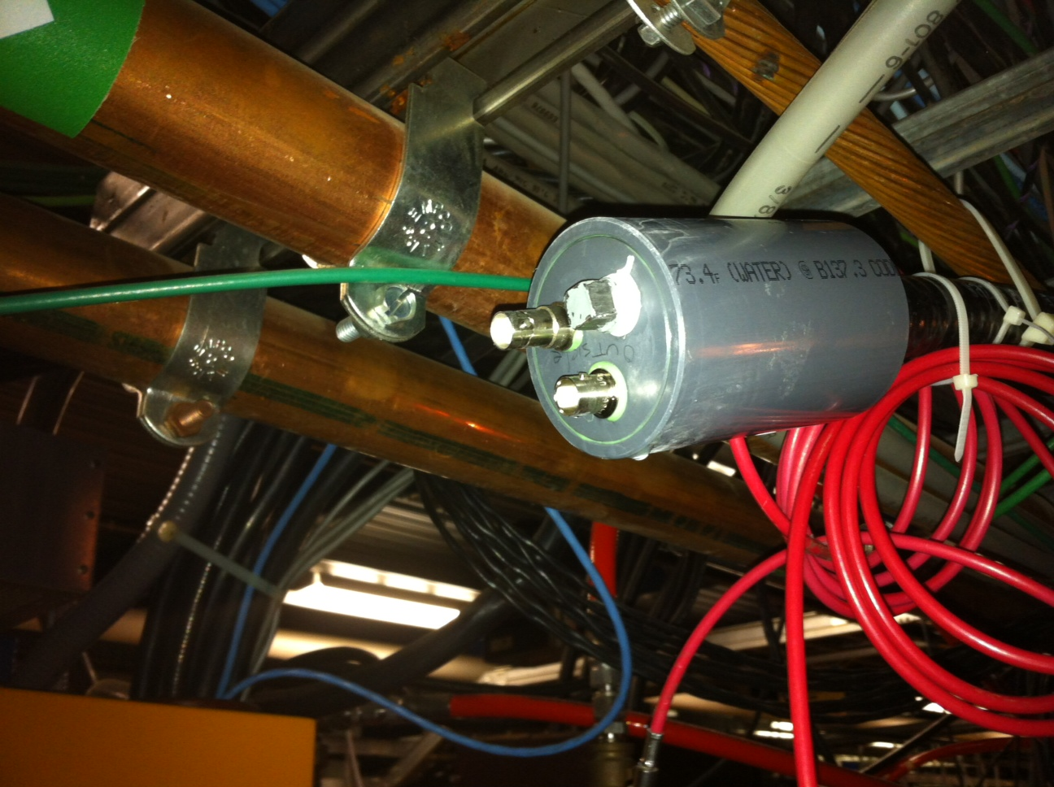 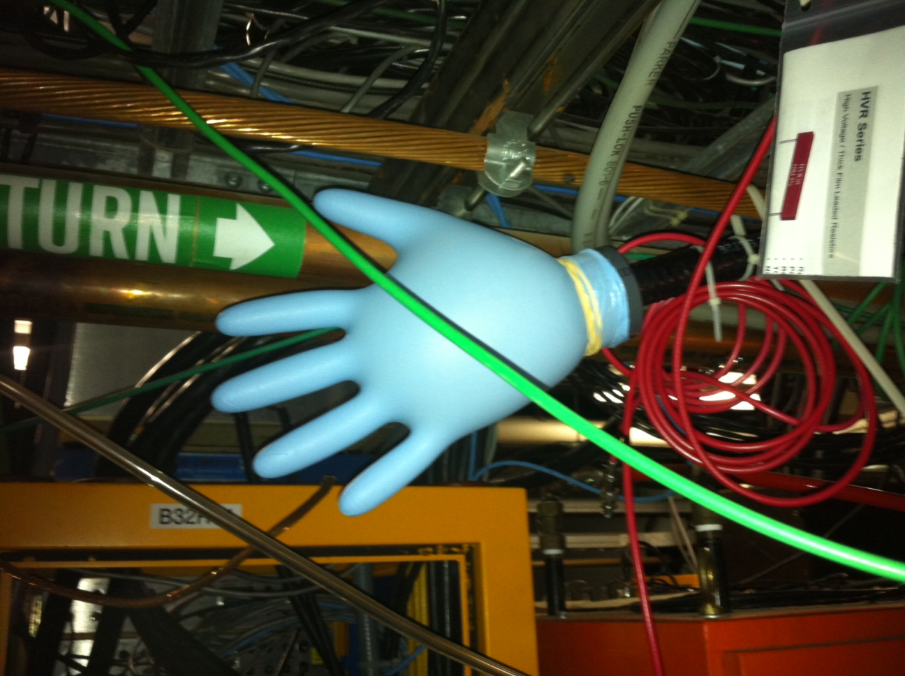

Figure 12: Gas leak test arrangement is shown at left. The downstream end of the cable was plugged and a glove was fitted over the end of the connector while 5 psig gas pressure was applied to the cable. The inflated glove indicates that the BNC and SHV feed throughs are leaking. The leaking feed throughs indicate that potting of the terminations will be required to achieve a gas tight system.

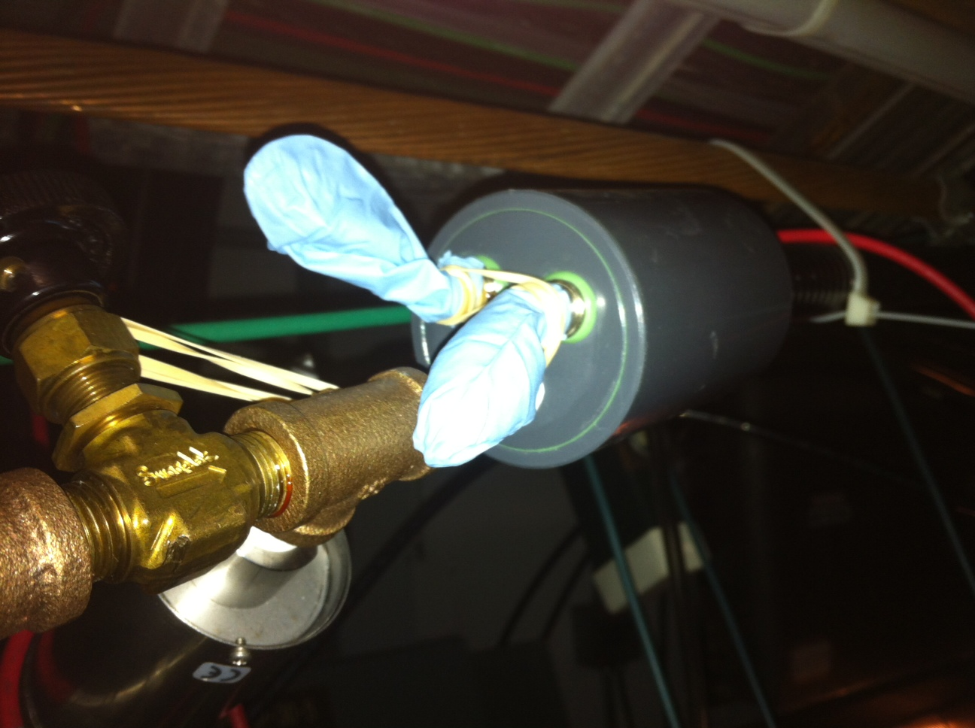

Added shrink wrap to the BNC and SHV connectors Friday afternoon to attempt sealing the leaky connectors. The leak rate before and after application of the heat shrink tubing is shown below. While the heat shrink tubing improved the sealing, it appears likely that some form of potting will be required to prevent leaking through the center conductor/insulator junction.

The TLM cable outer conductor is a corrugated 7/8” diameter copper tube which is butt welded along its entire length. Gas leaks through the shield should not be possible. Some care needs to be taken when installing the cable adapter to the cable. A possible gas leakage path is that gas could enter between the outer PE shield and outer copper conductor if sufficient epoxy is not applied to seal this joint (see Figure 4). The outer PE shield could become pressurized as a result. The 10 foot TLM section was repurposed from another application and has some nicks and cuts through which gas could be passed.

Second Gas Leak Test Note (following end cap epoxy potting)

A gas leak test is warranted with the new end cap design.